Class Test 03
PL/SQL
Part 01:
- Write a query that can multiply two numbers taking input from user.
- Write a query that can add two numbers if the numbers are equal. Use CASE Statement.
- Write a query that can check if two strings are equal or not. Use IF-THEN-ELSIF Statement.
- Write a query that can multiply two numbers. If the result obtained is less than 100, Hi is displayed, if the result obtained is more than 100, Bye is displayed and if the result obtained is equal to 100, ADBMS is displayed. Use IF-THEN-ELSIF Statement
- Write a query that can check if two numbers are equal or not. Use CASE Statement.

Part 02:
To solve the following use the scott schema
- Write a query that can display the salary of employee ALLEN. If ALLEN’s salary is greater than 2000 display ‘SALARY GREATER THAN 2000’ and If not then display ‘SALARY LESS THAN 2000’.
- Write a query that can ask user to input the EMPNO of employee WARD and display his salary.
- Write a query that can ask user to input the EMPNO of employee BLAKE,CLARK and TURNER and display their respective salary.
- Write a query that can ask user to input the EMPNO of employee BLAKE,CLARK and TURNER and display their respective salary, add the salaries and display the total.
- Write a query that displays the commission of employee SMITH. If SMITH’s commission is NULL. Display ‘NOT APPLICABLE FOR COMMISSION’

Part 03:
To solve the following use the scott schema
- Write a query that can display the salary of employee JONES three times using basic loop.
- Write a query that can display the salary of employee JONES three times using while loop.
- Write a query that can display the salary of employee JONES three times using for loop.
- Create a function that returns the total number of departments.
- Create a procedure to update the salary of employee Allen to 100.

**After solving the above questions using Oracle 10g, write the PL/SQLs in a MS Word document (Write down the answer and give screenshot of the result of the query. The name of the document MUST be your ID and the PL/SQLs MUST be numbered accordingly) and upload it in the provided link in your VUES account

Part: 01
- Write a query that can multiply two numbers taking input from user.
DECLARE
num1 NUMBER := :num1;
num2 NUMBER := :num2;
result NUMBER;
BEGIN
result := num1 * num2;
DBMS_OUTPUT.PUT_LINE('Multiplication Result: ' || result);
END;
/
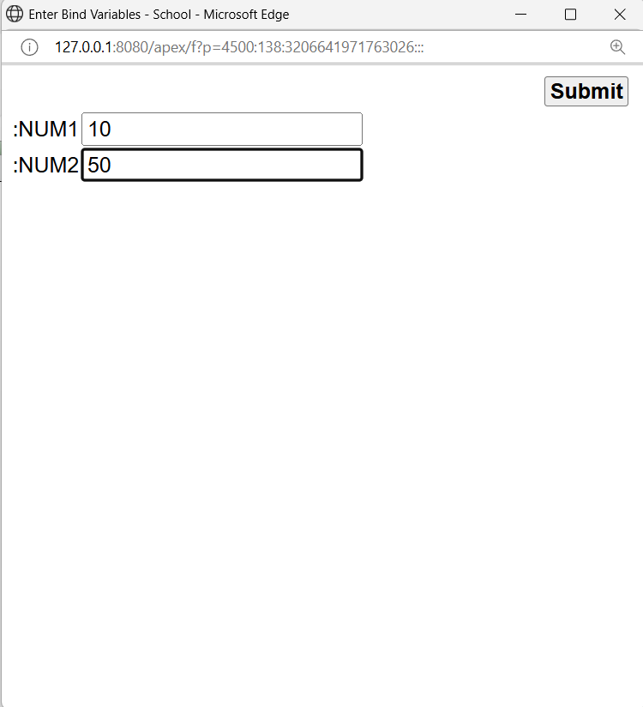
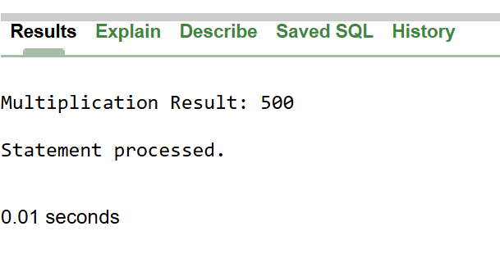
- Write a query that can add two numbers if the numbers are equal. Use CASE Statement.
DECLARE
num1 NUMBER := :num1;
num2 NUMBER := :num2;
result NUMBER;
BEGIN
CASE
WHEN num1 = num2 THEN
result := num1 + num2;
DBMS_OUTPUT.PUT_LINE('Numbers are equal. Sum = ' || result);
ELSE
DBMS_OUTPUT.PUT_LINE('Numbers are not equal. No addition performed.');
END CASE;
END;
/

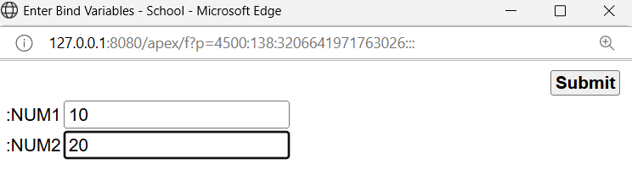
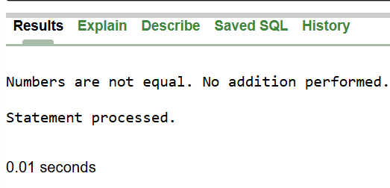
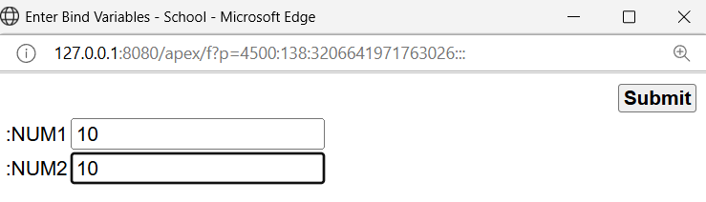
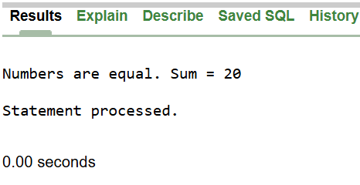

3. Write a query that can check if two strings are equal or not. Use IF-THEN-ELSIF Statement.
DECLARE
str1 VARCHAR2(100) := 'HELLO';
str2 VARCHAR2(100) := 'HELLO';
BEGIN
IF str1 = str2 THEN
DBMS_OUTPUT.PUT_LINE('Strings are equal.');
ELSIF str1 != str2 THEN
DBMS_OUTPUT.PUT_LINE('Strings are not equal.');
END IF;
END;
/
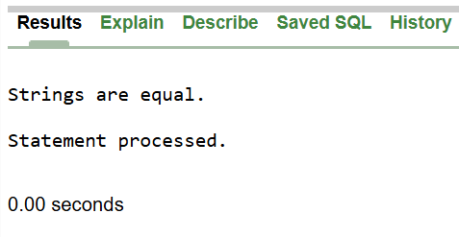
4. Write a query that can multiply two numbers. If the result obtained is less than 100, Hi is displayed, if the result obtained is more than 100, Bye is displayed and if the result obtained is equal to 100, ADBMS is displayed. Use IF-THEN-ELSIF Statement
DECLARE
num1 NUMBER := 10;
num2 NUMBER := 10;
result NUMBER;
BEGIN
result := num1 * num2;
IF result < 100 THEN
DBMS_OUTPUT.PUT_LINE('Hi');
ELSIF result > 100 THEN
DBMS_OUTPUT.PUT_LINE('Bye');
ELSIF result = 100 THEN
DBMS_OUTPUT.PUT_LINE('ADBMS');
END IF;
END;
/
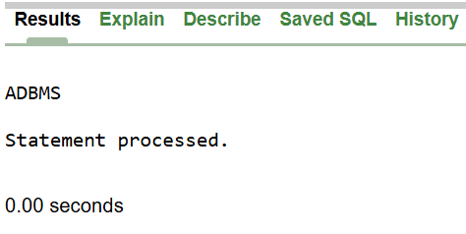

5. Write a query that can check if two numbers are equal or not. Use CASE Statement.
DECLARE
num1 NUMBER := 100;
num2 NUMBER := 100;
BEGIN
CASE
WHEN num1 = num2 THEN
DBMS_OUTPUT.PUT_LINE('Numbers are equal.');
ELSE
DBMS_OUTPUT.PUT_LINE('Numbers are not equal.');
END CASE;
END;
/

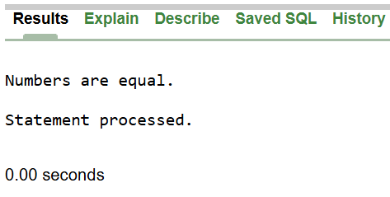

Part: 02
6. Write a query that can display the salary of employee ALLEN. If ALLEN’s salary is greater than 2000 display ‘SALARY GREATER THAN 2000’ and If not then display ‘SALARY LESS THAN 2000’.
DECLARE
a_sal NUMBER;
BEGIN
SELECT sal INTO a_sal FROM emp WHERE ename = 'ALLEN';
IF a_sal > 2000 THEN
DBMS_OUTPUT.PUT_LINE('SALARY GREATER THAN 2000');
ELSE
DBMS_OUTPUT.PUT_LINE('SALARY LESS THAN 2000');
END IF;
END;
/
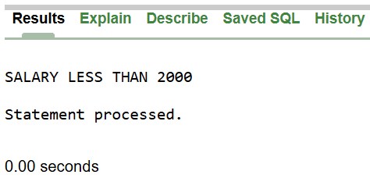
7. Write a query that can ask user to input the EMPNO of employee WARD and display his salary.
DECLARE
w_empno NUMBER;
w_sal NUMBER;
BEGIN
w_empno := :w_empno;
SELECT sal INTO w_sal FROM emp WHERE empno = w_empno AND ename = 'WARD';
DBMS_OUTPUT.PUT_LINE('Salary of WARD: ' || w_sal);
END;
/
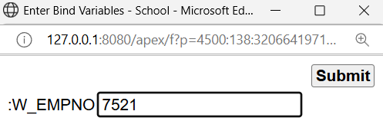 | 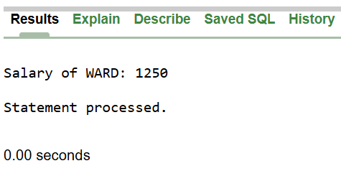

8. Write a query that can ask user to input the EMPNO of employee BLAKE, CLARK and TURNER and display their respective salary.
DECLARE
empno_blake NUMBER;
empno_clark NUMBER;
empno_turner NUMBER;
salary_blake NUMBER;
salary_clark NUMBER;
salary_turner NUMBER;
BEGIN
empno_blake := :empno_blake;
empno_clark := :empno_clark;
empno_turner := :empno_turner;

SELECT sal INTO salary_blake FROM emp WHERE empno = empno_blake AND ename = 'BLAKE';
SELECT sal INTO salary_clark FROM emp WHERE empno = empno_clark AND ename = 'CLARK';
SELECT sal INTO salary_turner FROM emp WHERE empno = empno_turner AND ename = 'TURNER';

DBMS_OUTPUT.PUT_LINE('Salary of BLAKE: ' || salary_blake);
DBMS_OUTPUT.PUT_LINE('Salary of CLARK: ' || salary_clark);
DBMS_OUTPUT.PUT_LINE('Salary of TURNER: ' || salary_turner);
END;
/
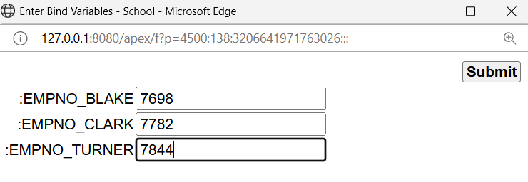
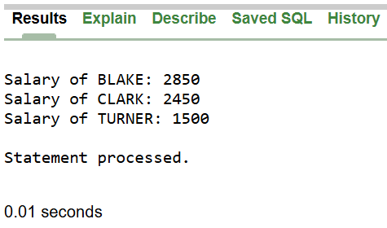

9. Write a query that can ask user to input the EMPNO of employee BLAKE, CLARK and TURNER and display their respective salary, add the salaries and display the total.
DECLARE
empno_blake NUMBER;
empno_clark NUMBER;
empno_turner NUMBER;
salary_blake NUMBER;
salary_clark NUMBER;
salary_turner NUMBER;
total_salary NUMBER;
BEGIN
empno_blake := :empno_blake;
empno_clark := :empno_clark;
empno_turner := :empno_turner;

SELECT sal INTO salary_blake FROM emp WHERE empno = empno_blake AND ename = 'BLAKE';
SELECT sal INTO salary_clark FROM emp WHERE empno = empno_clark AND ename = 'CLARK';
SELECT sal INTO salary_turner FROM emp WHERE empno = empno_turner AND ename = 'TURNER';

total_salary := salary_blake + salary_clark + salary_turner;

DBMS_OUTPUT.PUT_LINE('Salary of BLAKE: ' || salary_blake);
DBMS_OUTPUT.PUT_LINE('Salary of CLARK: ' || salary_clark);
DBMS_OUTPUT.PUT_LINE('Salary of TURNER: ' || salary_turner);

DBMS_OUTPUT.PUT_LINE('Total Salary: ' || total_salary);
END;
/

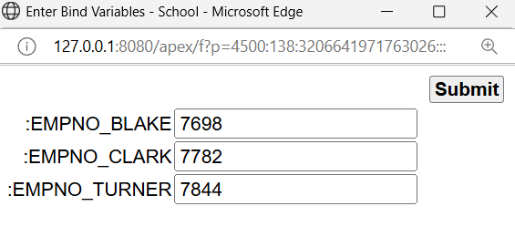 | 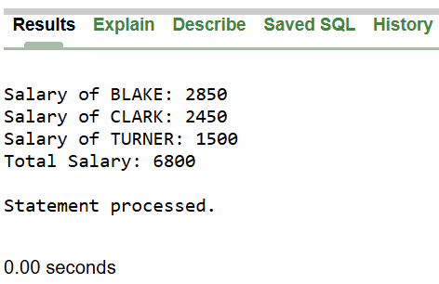

10. Write a query that displays the commission of employee SMITH. If SMITH’s commission is NULL. Display ‘NOT APPLICABLE FOR COMMISSION’
DECLARE
s_comm NUMBER;
BEGIN
SELECT COMM INTO s_comm FROM emp WHERE ename = 'SMITH';

IF s_comm IS NULL THEN
DBMS_OUTPUT.PUT_LINE('NOT APPLICABLE FOR COMMISSION');
ELSE
DBMS_OUTPUT.PUT_LINE('Commission: ' || s_comm);
END IF;
END;
/
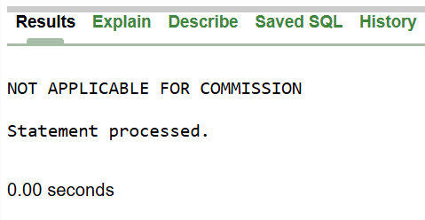

Part: 03
11. Write a query that can display the salary of employee JONES three times using basic loop.
DECLARE
j_salary NUMBER;
counter NUMBER := 1;
BEGIN
SELECT sal INTO j_salary FROM emp WHERE ename = 'JONES';

LOOP
DBMS_OUTPUT.PUT_LINE('JONES Salary: ' || j_salary);
counter := counter + 1;
IF counter > 3 THEN
EXIT;
END IF;
END LOOP;
END;
/
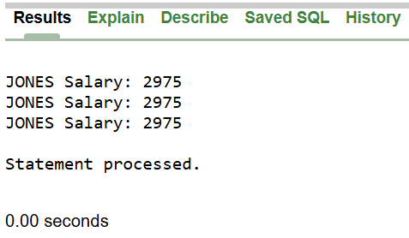
12. Write a query that can display the salary of employee JONES three times using while loop.
DECLARE
j_salary NUMBER;
counter NUMBER := 1;
BEGIN
SELECT sal INTO j_salary FROM emp WHERE ename = 'JONES';
WHILE counter <= 3 LOOP
DBMS_OUTPUT.PUT_LINE('JONES Salary: ' || j_salary);
counter := counter + 1;
END LOOP;
END;
/
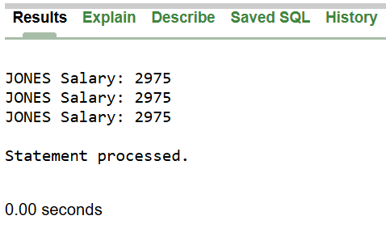

13. Write a query that can display the salary of employee JONES three times using for loop.
DECLARE
j_salary NUMBER;
BEGIN
SELECT sal INTO j_salary FROM emp WHERE ename = 'JONES';
FOR i IN 1..3 LOOP
DBMS_OUTPUT.PUT_LINE('JONES Salary: ' || j_salary);
END LOOP;
END;
/
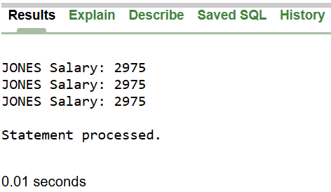
14. Create a function that returns the total number of departments.
CREATE OR REPLACE FUNCTION get_total_depts
RETURN NUMBER IS
total_depts NUMBER;
BEGIN
SELECT COUNT(*) INTO total_depts FROM dept;
RETURN total_depts;
END;
/

BEGIN
DBMS_OUTPUT.PUT_LINE('Total number of departments: ' || get_total_depts);
END;
/
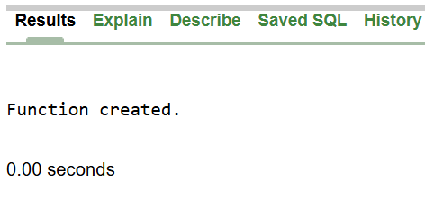 | 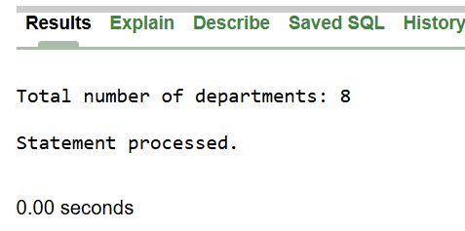

15. Create a procedure to update the salary of employee Allen to 100.
CREATE OR REPLACE PROCEDURE update_allen_salary IS
BEGIN
UPDATE emp SET sal = 100
WHERE ename = 'ALLEN';
END;
/



